**Practical No: 069**

**Aim: - Implement radial basis functions using surrogate modeling**

**SurrogateModelOptim**

SurrogateModelOptim is a Julia package for the optimisation of expensive functions. The surrogate model is based on an ensemble of Radial Basis Function interpolants with adaptive axis scaling.

**Installation**

Run this code only once to install dependencies.

using Pkg

Pkg.add("SurrogateModelOptim")

This package is intended to be used for functions which are expensive. We consider an expensive

function rosenbrock_2D that evaluates in several minutes to days.

A julia function can be optimized with

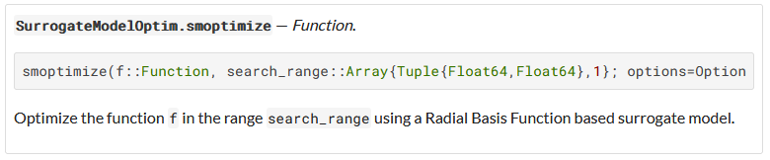

The goal is to minimize the function output

**Step 1:** Creating a generic function

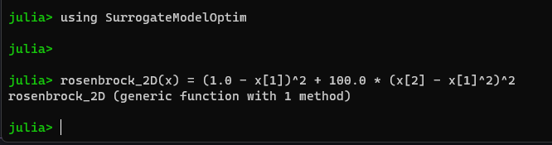

**Step 2:** Creating search range

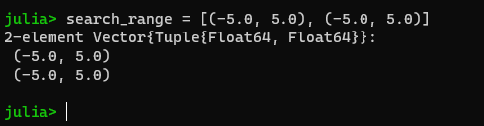

**Step 3:** Optimizing the function with the given search range

